|  |  |
| --- | --- |
| **Soal Praktikum**  *Practicum Case* |  |
| ISYS6028  Database Systems |
| **Teknik Informatika**  *Computer Science* | O221-ISYS6028-DW01-05 |
| **Periode Berlaku Mulai** Semester Ganjil 2017/2018  ***Valid on*** *Odd Semester Year* 2017/2018 | **Revisi 00**  *Revision 00* |

**Learning Outcomes**

* Apply database language and SQL Programming language

## Topic

* Session 03 **-** SQL – Data Manipulation (1)
* Session 05 **-** SQL – Data Manipulation (3)

## Sub Topics

* Session 03
  + Insert Data
  + Delete Data
  + Update Data
  + Begin Trans
  + **Simple Query**
* Session 05
  + Quiz
  + String and Date Functions

**Tabel Relasional**

*Relational Table*

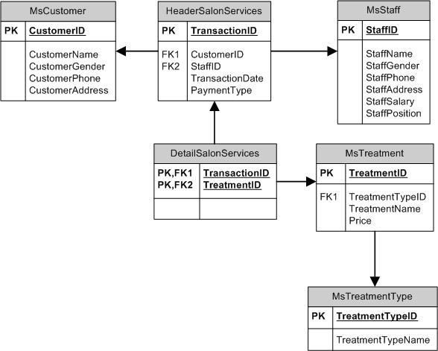

**Sintaks**

*Syntax*

[**Select**](http://www.1keydata.com/sql/sqlselect.html)  
SELECT { * | field_name [, …] }  
FROM table_name [, …]

[**Distinct**](http://www.1keydata.com/sql/sqldistinct.html)  
SELECT DISTINCT { * | field_name [, …] }  
FROM table_name [, …]

[**Where**](http://www.1keydata.com/sql/sqlwhere.html)  
SELECT { * | field_name [, …] }  
FROM table_name [, …]WHERE {condition}

[**Between**](http://www.1keydata.com/sql/sqlbetween.html)  
SELECT { * | field_name [, …] }  
FROM table_name [, …]WHERE field_name BETWEEN value1 AND value2

[**Like**](http://www.1keydata.com/sql/sqllike.html)  
SELECT { * | field_name [, …] }  
FROM table_name [, …]WHERE field_name LIKE {PATTERN}

## Soal

*Case*

1. Display all female staff’s data from MsStaff.

(**select**)

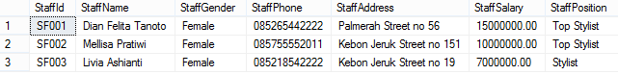

1. Display StaffName, and StaffSalary(obtained by adding ‘Rp.’ In front of StaffSalary) for every staff whose name contains ‘m’ character and has salary more than or equal to 10000000.

(**cast**, **like**)

C:\Users\AdityaMili\Desktop\BANK SOAL\Bank Case Making\04\new\2.png

1. Display TreatmentName, and Price for every treatment which type is 'message / spa' or 'beauty care'.

(**in**)

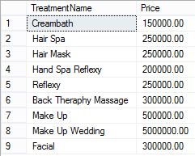

1. Display StaffName, StaffPosition, and TransactionDate (obtained from TransactionDate in Mon dd,yyyy format) for every staff who has salary between 7000000 and 10000000.

(**convert**, **between**)

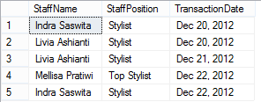

1. Display Name (obtained by taking the first character of customer’s name until character before space), Gender (obtained from first character of customer’s gender), and PaymentType for every transaction that is paid by ‘Debit’.

(**substring**, **charindex**, **left**)

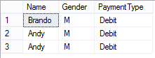

1. Display Initial (obtained from first character of customer’s name and followed by first character of customer’s last name in uppercase format), and Day (obtained from the day when transaction happened ) for every transaction which the day difference with 24th December 2012 is less than 3 days.

(**upper**, **left**, **substring**, **charindex**, **datename**, **weekday**, **datediff**, **day**)

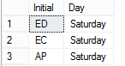

1. Display TransactionDate, and CustomerName (obtained by taking the character after space until the last character in CustomerName) for every customer whose name contains space and did the transaction on Saturday.

(**right**, **charindex**, **reverse**, **like**, **datename**, **weekday**)

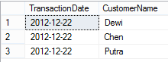

1. Display StaffName, CustomerName, CustomerPhone (obtained from customer’s phone by replacing ‘0’ with ‘+62’), and CustomerAddress for every customer whose name contains vowel character and handled by staff whose name contains at least 3 words.

(**replace**, **like**)

C:\Users\AdityaMili\Desktop\BANK SOAL\Bank Case Making\04\new\8.png

1. Display StaffName, TreatmentName, and Term of Transaction (obtained from the day difference between transactionDate and 24th December 2012) for every treatment which name is more than 20 characters or contains more than one word.

(**datediff**, **day**, **len**, **like**)

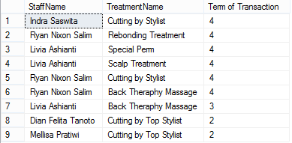

1. Display TransactionDate, CustomerName, TreatmentName, Discount (obtainedby changing Price data type into int and multiply it by 20%), and PaymentType for every transaction which happened on 22th day.

(**cast**, **day**)

